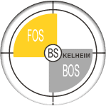
Organizations connected to globalization

WTO
http://www.wto.org/english/thewto_e/whatis_e/whatis_e.htm
http://www.wto.org/english/thewto_e/whatis_e/10mis_e/10m00_e.htm

UNO
http://www.un.org

The World Bank
http://www.worldbank.org

IMF
http://www.imf.org

NGOs
http://www.attac.org/?lang=en
http://www.fairtrade.org.uk

